**SOFTWARE DESIGN DESCRIPTION**

**(SDS DOCUMENT)**

**for**

**<OrderEase>**

Version 1.0

***By***

**Muhammad Musa AF22LHB-1940**

**Malaika-Gul-Faraz AF22LHB-2396**

***Supervisor***

**Zaka-Ur-Rehman**

***Associate Degree Program in Computer Science (2022-2024)***

**Table of Contents**

Revision History 3

1. Introduction: 5

2. Design methodology: 5

3. System overview: 5

4. Algorithm & Implementation 5

5. Architectural design: 5

6. Data Flow Diagram: 5

7. Class Diagram: 6

8. Sequence Diagram: 6

9. Activity Diagram: 6

10. ERD diagram: 6

11. User Interfaces: 6

12. Gantt Chart: 6

13. Conclusion: 7

14. Future Work: 7

15. References to any book, journal paper or website should properly be acknowledged. Please consistently follow the style. The following are few examples of different resources i.e. journal article, book, and website. 7

Revision History

|  |  |  |  |
| --- | --- | --- | --- |
| **Name** | **Date** | **Reason for changes** | **Version** |
|  |  |  |  |
|  |  |  |  |
|  |  |  |  |
|  |  |  |  |
|  |  |  |  |

**Application Evaluation History**

|  |  |
| --- | --- |
| **Comments (by committee)**  **\*include the ones given at scope time both in doc and presentation** | **Action Taken** |
|  |  |
|  |  |
|  |  |
|  |  |
|  |  |

**Supervised by**

**MUHAMMAD WASEEM**

Signature_

## Introduction:

In the rapidly advancing digital era, where technology permeates every aspect of our lives, some restaurants continue to rely on traditional methods, such as physical menus, manual waiter systems, and cash payments. This not only creates operational challenges but also affects the overall reputation of the restaurant. Recognizing the need for innovation, my objective is to design a comprehensive website that addresses these issues, providing a seamless and efficient ordering system for both customers and restaurant staff.

The proposed system begins with a simple yet effective solution: a QR code-based ordering system. Upon entering the restaurant, customers only need to scan the QR code displayed prominently. This action grants them access to the digital menu, eliminating the need for physical menus and facilitating a more hygienic and streamlined ordering process.

Once on the ordering platform, customers can peruse the menu at their own pace, selecting items and customizing their orders as desired. The intuitive interface ensures a user-friendly experience, allowing patrons to navigate through various categories, view images of dishes, and read detailed descriptions. After finalizing their orders, customers receive a confirmation, and the order seamlessly appears in the kitchen, alerting the staff to prepare the requested items.

Efficiency is further enhanced by incorporating secure online payment methods. Customers can pay using credit or debit cards, or through various online accounts, ensuring a hassle-free transaction process. For those who prefer cash payments, this option is still available. Upon completion of the payment, customers receive an electronic receipt, promoting a paperless environment. In the case of cash payments, a physical receipt is provided to maintain flexibility and cater to diverse customer preferences.

To keep customers informed and engaged, a real-time order tracker is implemented. This feature allows patrons to monitor the status of their orders, from preparation to delivery. Additionally, a countdown timer is provided to give customers an estimated time of arrival for their orders, managing expectations and reducing uncertainty.

Recognizing that waiting time can be perceived as a downside, the website goes a step further by offering entertainment options. Basic games are integrated into the platform, providing customers with a means to pass the time while enjoying a pleasant dining experience. This not only addresses potential concerns about prolonged waiting periods but also adds an element of enjoyment to the overall dining experience.

Furthermore, a designated section for customer feedback is incorporated, allowing patrons to express their opinions, share reviews, and submit complaints. This valuable input aids the restaurant in understanding customer preferences, identifying areas for improvement, and enhancing overall service quality. The feedback loop established through this platform contributes to a continuous cycle of improvement, fostering a customer-centric approach.

In conclusion, the proposed website revolutionizes the traditional restaurant experience by introducing a digital ordering system that prioritizes efficiency, convenience, and customer satisfaction. From the initial QR code scan to the secure online payment options, real-time order tracking, entertainment features, and feedback mechanisms, every aspect is meticulously designed to elevate the dining experience for both customers and restaurant staff. Embracing technology in this manner ensures that the restaurant stays ahead in the competitive landscape while catering to the evolving preferences of the modern consumer.

**Fearutes:**

In the contemporary landscape of dining experiences, the integration of technology into the restaurant industry has become imperative. With the aim of enhancing customer convenience and streamlining the ordering process, I envision designing a website tailored for a restaurant that offers a modern and efficient way for patrons to place orders.

The process begins with a simple yet powerful feature – a QR code. Placed prominently at the restaurant's entrance or on each table, this QR code serves as the gateway to a digital ordering system. Customers merely need to scan the code with their smartphones to gain instant access to the restaurant's website. This eliminates the need for physical menus, promoting a hygienic and contactless interaction.

Once on the website, customers can explore an interactive and user-friendly menu. Categories of dishes, vibrant images, and detailed descriptions create an immersive experience, allowing patrons to make informed choices. A convenient search bar is also incorporated, enabling customers to quickly locate their favorite dishes or explore new ones.

Placing an order becomes a seamless process through the intuitive interface. Customers can add items to their virtual cart, customize their orders, and review their selections before confirming. The inclusion of an online payment feature adds an extra layer of convenience. Secure payment options allow customers to complete transactions effortlessly using credit or debit cards, ensuring a smooth and contact-free payment process.

The search bar extends its utility beyond menu exploration. It serves as a practical tool for customers seeking a specific dish amidst an extensive menu. Whether searching for a particular cuisine, ingredient, or dish name, this feature caters to diverse preferences and enhances the overall user experience.

The website also prioritizes transparency and efficiency. Customers are provided with real-time updates on their orders, from confirmation to preparation and delivery. This fosters a sense of engagement and anticipation, ensuring that patrons are well-informed about the progress of their dining experience.

In conclusion, this envisioned restaurant website blends innovation with practicality, offering a seamless digital ordering experience for customers. By harnessing the power of QR codes, interactive menus, online payments, and a versatile search bar, the website not only streamlines the ordering process but also elevates the overall dining experience. This forward-thinking approach aligns with the evolving expectations of modern consumers, creating a win-win scenario for both the restaurant and its valued patrons.

* **Scan-able Menu:**

In an era defined by technological convenience, our restaurant's website is at the forefront of innovation, boasting a scan-able menu accessible through a QR code. This forward-thinking approach embraces the ease of technology, allowing customers to effortlessly delve into our digital platform by a simple scan. As the QR code is activated, patrons are ushered into a world of culinary possibilities presented through an extensive and visually appealing menu. This contactless method not only aligns with contemporary hygiene standards but also promises a seamless and engaging browsing experience. The QR code serves as a portal, seamlessly connecting diners to a virtual culinary journey where they can explore, select, and customize their orders with utmost ease. This intuitive integration of technology not only enhances accessibility but also elevates the overall dining encounter, reflecting our commitment to combining culinary excellence with the utmost convenience for our valued patrons.

* **Customizable menu:**

In the pursuit of culinary perfection, our website is dedicated to tailoring your dining experience with unparalleled precision. At the heart of this commitment lies our customizable menu feature, inviting patrons to embark on a culinary journey curated to their exact preferences. The flexibility inherent in this offering allows customers to effortlessly fine-tune their orders. From adjusting the quantity of each dish to adding personalized notes, every detail is within their control. This empowerment extends further as patrons craft a unique order list, reflecting their individual tastes and desires.

This level of customization transcends the conventional dining experience, providing a platform where customers can truly orchestrate their ideal culinary adventure. The seamless ability to accommodate individual preferences not only reflects our dedication to culinary excellence but also underscores our commitment to delivering an immersive and personalized dining encounter that goes beyond expectations.

* **Real time Order Tracking:**

In a commitment to elevate transparency and anticipation in the dining experience, our website takes a pioneering step with the introduction of real-time order tracking. Once a customer places an order, our innovative platform empowers them with the ability to monitor its progress in a dynamic and engaging manner, thanks to a visible timer. This feature serves as a digital window into the behind-the-scenes activity, keeping patrons informed about the various stages their order undergoes—from confirmation to preparation and ultimately to delivery.

By providing this real-time tracking functionality, we not only address the common concerns of waiting times but also transform the waiting period into an interactive and anticipatory element of the overall dining journey. Customers are no longer left in the dark about the status of their orders, fostering a sense of connection with the culinary process. This feature represents our dedication to enhancing the customer experience, turning each transaction into a participatory and engaging event, all while reducing uncertainty and ensuring a seamless dining journey.

* **Mini Games:**

Dedicated to enriching the dining experience, our website introduces a real-time order tracking feature, enhancing transparency and anticipation. After placing an order, customers gain immediate insight into its progress through a visible timer. This dynamic functionality offers a digital window into the various stages of order fulfillment, from confirmation to preparation and delivery. By keeping patrons informed and engaged, we aim to reduce uncertainty and transform the waiting period into an interactive element of their dining journey. This innovative addition not only addresses concerns about waiting times but also exemplifies our commitment to leveraging technology to create a more connected and enjoyable experience for our valued customers.

* **Dark Mode:**

In an effort to cater to the diverse preferences of our users, our website goes beyond the conventional and introduces support for both dark and light themes. This thoughtful feature is designed to empower users to personalize their visual experience, ensuring optimal comfort whether they are browsing during the day or night. The adaptability of dark mode not only enhances accessibility but also adds a touch of personalization, recognizing that each user has unique preferences when it comes to the visual presentation of a digital platform. By providing this choice, we prioritize user comfort, acknowledging that the browsing experience is subjective and should be tailored to individual preferences, ultimately contributing to a more inclusive and enjoyable interaction with our website.

* **Customer Support:**

Committed to exceptional service, our website provides access to a responsive customer support team. Any issues, queries, or concerns related to our services can be addressed promptly. This proactive approach ensures that customers feel supported and valued throughout their interaction with our platform.

* **Complain & Reviews:**

Fostering a feedback loop, our website includes a dedicated space for customer input. The complain box welcomes suggestions, ideas, and critiques, providing valuable insights to enhance our services. Customers can also share their reviews, contributing to a transparent and collaborative relationship.

* **Secure Payment Methods:**

Prioritizing convenience and security, our website facilitates online payments. Customers can make transactions seamlessly through our secure platform, choosing from a variety of payment methods. This ensures a hassle-free and trustworthy financial interaction.

* **Rating:**

Encouraging customer engagement, our website invites users to provide ratings for our services and food. This feedback mechanism allows us to continually refine and improve, based on the real-time evaluations of our valued patrons.

* **Records:**

Adding a business-oriented feature, our website incorporates a robust daily revenue calculation tool. This essential feature goes beyond the customer-facing aspects, offering valuable insights into the restaurant's performance. By tracking and analyzing daily revenue, the website becomes a strategic tool for decision-making. This data-driven approach aids in formulating effective business strategies, identifying peak periods, optimizing resource allocation, and making informed decisions to enhance overall operational efficiency. The incorporation of this feature reflects our commitment to not only providing a seamless customer experience but also to empowering the restaurant management with actionable data for strategic planning and sustained success.

## Design methodology:

Creating a food ordering website is a comprehensive process that involves careful research, meticulous planning, and strategic execution. In this detailed methodology, we will delve into each step to provide a thorough understanding of the entire process.

* + **Research Design:**

To initiate the development of a food ordering website, it's crucial to conduct thorough research. This involves understanding the current landscape of food ordering websites. Reviewing existing platforms and analyzing their features, user interfaces, and functionalities is essential. This initial phase sets the foundation for identifying trends, potential innovations, and areas for improvement.

* **Requirement Analysis:**

Collaboration with stakeholders, including faculty, students, and administrators, plays a pivotal role in identifying the specific requirements for the website. Surveys and interviews are conducted to gather information regarding user preferences, expectations, and any unique needs. This phase aims to create a comprehensive list of features that the website should incorporate to meet the diverse needs of its users.

* **Planning and Framework Selection:**

Once the requirements are identified, the next step involves planning and selecting an appropriate framework for the website. Factors such as scalability, ease of use, and customization options are considered in choosing the framework (e.g., WordPress, Drupal). A detailed project plan is outlined, encompassing timelines, milestones, and resource allocation to ensure a smooth development process.

* **Content Development:**

Crafting a compelling content strategy is essential for the success of any website. This involves defining the information architecture, navigation, and content types required for the food ordering platform. Collaboration with subject matter experts is crucial in developing and curating relevant, engaging, and accurate content that aligns with the website's goals and user expectations.

* **Design and Development:**

The design and development phase is where the visual and functional aspects of the website come to life. A design team is engaged to create wireframes and mockups based on the gathered requirements. Responsive design principles are implemented to ensure accessibility across various devices. The actual development involves using HTML, CSS, JavaScript, and integrating backend systems to ensure seamless operations and a user-friendly experience.

* **Testing and Quality Assurance:**

Rigorous testing is conducted to ensure the website's functionality, usability, and compatibility across different browsers and devices. This phase is crucial in identifying and resolving any bugs or issues. Feedback from users and stakeholders is collected to iterate and improve the website, ensuring a high level of quality before deployment.

* **Deployment and Maintenance:**

Once the website is thoroughly tested and refined, it is deployed on a secure server. This phase involves a careful transition from the old system to the new one. Establishing a maintenance plan is essential for the continuous upkeep of the website. Regular updates, security patches, and ongoing support contribute to the website's stability and longevity.

* **Evaluation:**

The final step involves evaluating the website's performance against predefined metrics. User engagement, traffic analytics, and feedback from users and stakeholders are analyzed. This evaluation provides insights into the website's success and areas that may require further enhancement. Continuous monitoring and analysis contribute to the ongoing improvement and optimization of the food ordering platform.

In conclusion, the methodology for crafting a food ordering website is a comprehensive process that involves strategic planning, collaboration with stakeholders, meticulous development, and continuous evaluation. Each phase plays a crucial role in ensuring the website's success in meeting user needs and staying competitive in the dynamic online food ordering industry.

## System overview:

**Key Features:**

* **Scan-able menu:** You can access to menu through QR code. You just need to scan the QR code and it will take you to the website where you are able to see the menu.
* **Customizable menu:** You can customize the quantity of food that you want to order and add it to your order list.
* **Real time Order Tracking:** Once you have made the order it will show you the timer that will help you to track your order.
* **Mini Games:** I am going to add some mini games to my website that will help you to pass your time without getting bored.
* **Dark Mode:** This website will support dark and light themes, offering a customizable experience.
* **Customer Support:** I am giving you a responsive team that will help you with your issues regarding to our services.
* **Complain & Reviews:** There is a complain box where you can submit your complains or ideas that will help us to improve our services. You can also put your reviews about us.
* **Secure Payment Methods:** You can make you payments online through our website.
* **Rating:** You can also give rating to our services or food.
* **Records:** This website will also calculate daily base revenue.

## Algorithm & Implementation

* **User Authentication:**

The website needs a way to verify users' identities before allowing them access to personalized features. Here's a simplified algorithm:

**Algorithm:**

1. Check if the user is authenticated (logged in).

2. Fetch the user and course information from the database based on provided IDs.

3. If both the user and course exist, add the course to the list of enrolled courses for the user.

4. Return a success message if enrollment is successful; otherwise, notify the user if there's an issue.

**Implementation:**

• Use a server-side language (like PHP or Node.js) for handling user authentication logic.

• Safely store user passwords using a secure hashing algorithm.

• Store user credentials in a database.

* Food Order:

**Algorithm:**

1. Check if the user is authenticated (logged in).

2. Fetch the user and order information from the database based on provided stock.

3. If the item exist, add the item to the list of order for the user.

4. Return a success message if order is added successful; otherwise, notify the user if there's an issue.

**Implementation:**

• Connect item requests to the user's account in the database.

• Handle errors gracefully, informing users about any problems during enrollment

## Architectural design:

## 

## Data Falow Diagram:

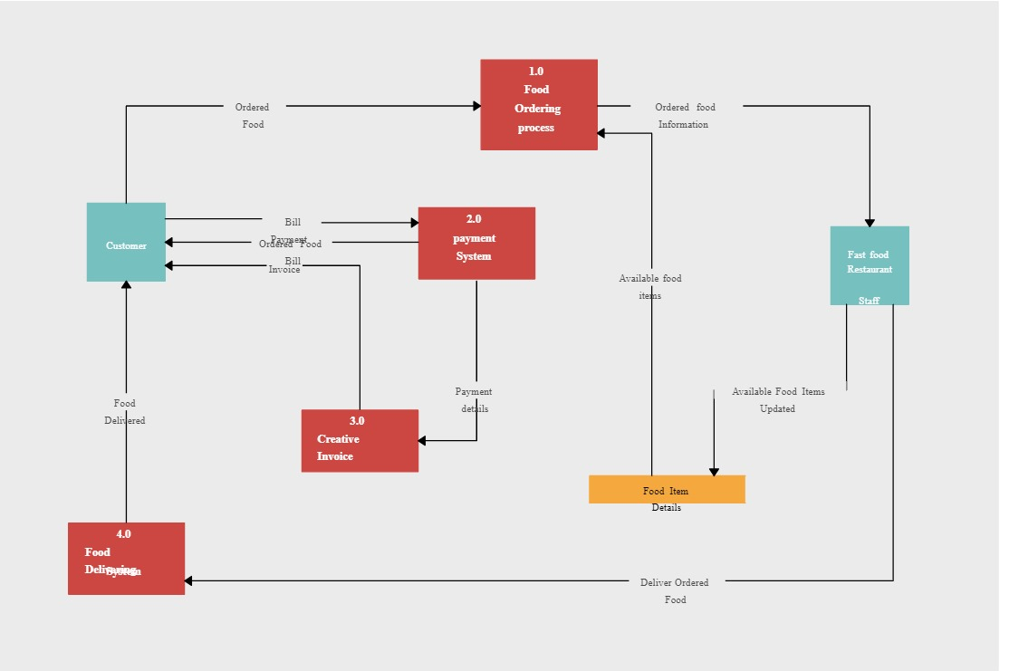

## Class Diagram:

## 

## 

## Sequence Diagram:

## 

## Activity Diagram:



## ERD diagram:

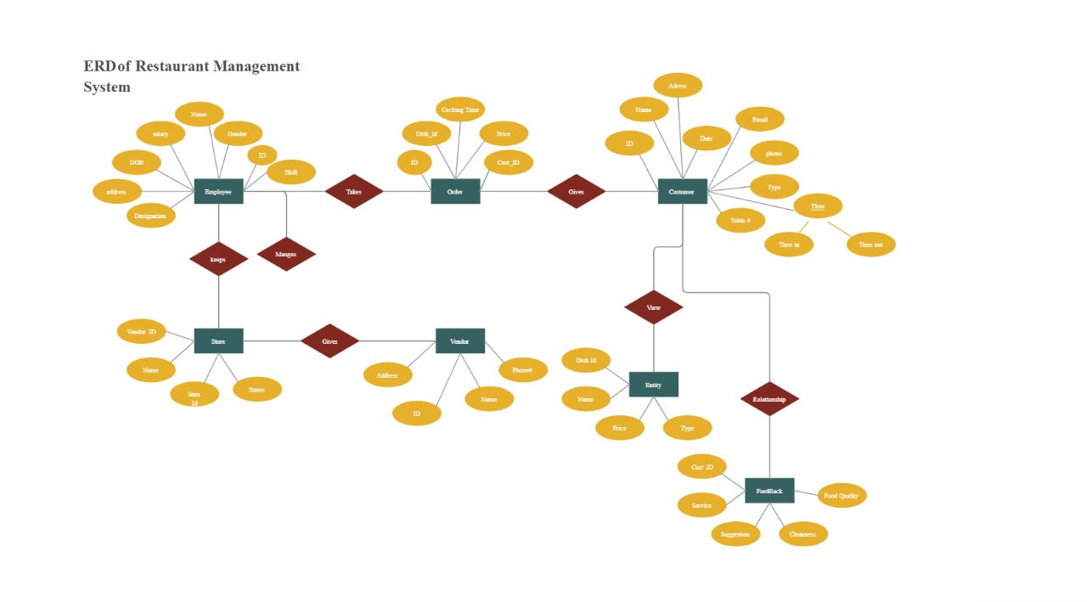

## User Interfaces:

## 

## 

## Gantt Chart:

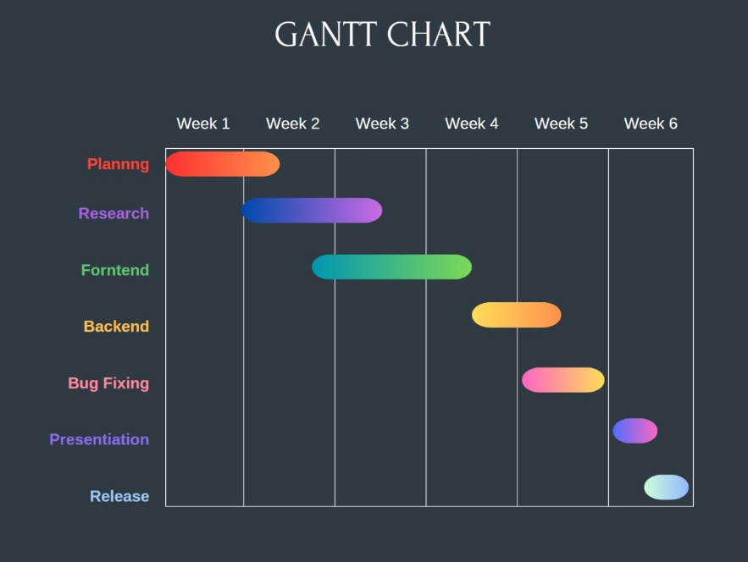

## Conclusion:

## Future Work:

## References to any book, journal paper or website should properly be acknowledged. Please consistently follow the style. The following are few examples of different resources i.e. journal article, book, and website.

52nz